Math 8 Application 2 Name ________________________
Show all your work!
1. Circle the letter that represents the approximate location on the number line of $\sqrt{65}$.  A B C D  0 5 10 15 | 2. Write using a negative exponent:  $\frac{1}{8}$ = | 3. Solve for x:  X⁴ = 81
4. Write in standard notation.  2.45 ∙ 10⁻⁴ | 5. Write the sum in scientific notation.  (4.2 ∙ 10³) + (3 ∙ 10³) = | 6. Solve for x.  8x – 15 = 5x + 7
7. If the line segment below is reflected over the x axis, what are the coordinates of the endpoints?  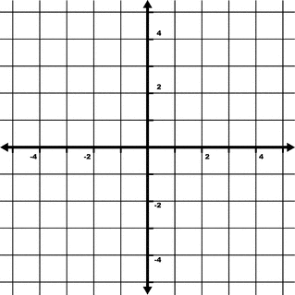 | 8. Find the length of side a below.  a 25 in.  20 in. | 9. Find the measure of angle b.  37◦  b
10. . Put the following rational numbers in order from smallest to largest.  1.3, $\frac{3}{2}$, 1.03, $\frac{7}{5}$ | 11. Estimate the product below.  45,386 ∙ 398 | 12. Write the fraction as a percent. $\frac{3}{8}$
13. Jonah rented a surfboard at the beach. The cost was $5 plus $3 for every hour rented. Write an equation for the function. | 14. Graph the function.  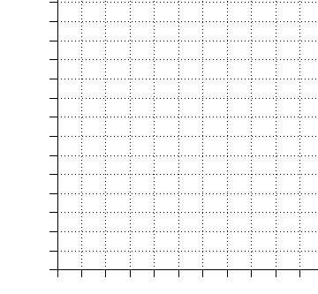 | 15. Complete the table.
  Number of hours | Total cost of rental
  1
  2
  3
  6
16. At Julie’s store, if she increases the price of her product by 40% in order to make a profit, what should she sell a product for that cost her $30? | 17. Find the volume of a cone with a radius of 7 mm and a height of 9 mm. | 18. Sara traveled 576 miles in 9 hours. What was her rate of speed in miles per hour?
19. Juan’s quiz scores are 70, 80, 55, 95, and 100. What is the mean of his quizzes? | 20. Fred made six 8 ounce chocolate bars. How many pounds of chocolate is this? | Number correct  5 minutes_______  Total___________

